Third: communicate with stakeholders
Construct an email or slack message that is understandable to a product or business leader who is not familiar with your day-to-day work. Summarize the results of your investigation. Include:
- Key data quality issues and outstanding questions about the data
df1 (Product Data):
- Removed Unneeded Columns: The column CATEGORY_4 was dropped as it was likely unnecessary.
- Filled Missing Categories: Missing values in categories like CATEGORY_1, CATEGORY_2, CATEGORY_3, MANUFACTURER, and BRAND were replaced with "Unknown."
- Cleaned Missing Barcodes: Rows with missing barcodes were removed to ensure no incomplete product data.
- Standardized Barcodes: Barcodes were converted from numeric to string format to prevent any issues with leading zeros or precision loss.
- Removed Duplicates: Any duplicate product data rows were deleted to ensure data accuracy.
df2 (Transaction Data):
- Date Format Issues: PURCHASE_DATE and SCAN_DATE were converted to proper date formats, with invalid dates being coerced into NaT (Not a Time).
- Numeric Conversion: FINAL_QUANTITY and FINAL_SALE columns were converted to numeric values, with invalid data being set to NaN.
- Cleaned Missing Barcodes: As with df1, rows with missing barcodes were removed to maintain data integrity.
- Filled Missing Sales Data: Any missing values in the FINAL_QUANTITY and FINAL_SALE columns were replaced with zero (0).
df3 (User Data):
- Date Formatting Issues: Both CREATED_DATE and BIRTH_DATE were converted to proper datetime formats, with invalid dates being coerced into NaT.
- Default Language: Missing LANGUAGE values were set to "en" (English) as a default.
- Genders Cleaned: Various gender-related inconsistencies (e.g., "female" vs. "Female") were standardized, and missing or unknown gender values were replaced with "Other."
- Standardized Gender Entries: Gender data was further cleaned by ensuring consistent capitalization and replacing a range of gender terms with standardized options (e.g., "non-binary" to "Non-Binary").
Key Data Quality Issues:
- Missing Values: For all datasets, missing values were filled (either with "Unknown" or zero, depending on context). However, some columns still have missing values that could be further explored for more granular insights.
- Inconsistent Date Formats: Dates in PURCHASE_DATE, SCAN_DATE, CREATED_DATE, and BIRTH_DATE had inconsistencies that were fixed.
- Barcode Validation: Missing barcodes were removed, but there may still be issues with the barcode data, such as incorrect or inconsistent formats, which should be reviewed further.
- Gender Data: Multiple variations of gender entries were cleaned, but additional categories might exist that should be reviewed.
Outstanding Questions:
- Are all missing values appropriately handled?: We replaced missing values with defaults (e.g., "Unknown", "en", zero), but it may be useful to evaluate whether a more context-specific fill is needed for certain columns.
- Are there any unexpected outliers in FINAL_QUANTITY and FINAL_SALE?: These columns were cleaned by setting missing values to zero, but it’s unclear if there are any extreme outliers that should be handled differently.
- Do we have enough data for certain categories?: Certain product and user categories may still have missing or incomplete information, which may affect downstream analysis.

- One interesting trend in the data
  - Use a finding from part 2 or come up with a new insight
Top manufacturer for each gender (Male & Female) group based on the total sales:
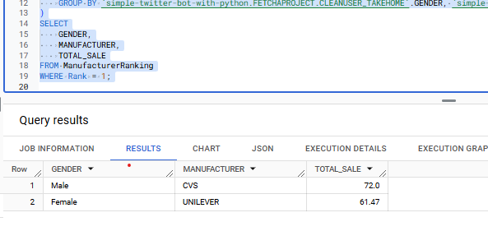
Male, CVS - Manufacturer, 72 - Total sales
Female, UNILEVER - Manufacturer, 61.47 - Total sales

- Request for action: explain what additional help, info, etc. you need to make sense of the data and resolve any outstanding issues
Request for Action:
Category Distribution Check: Ensure categories like CATEGORY_1, CATEGORY_2, and GENDER are well-represented, and investigate categories with many "Unknown" values.
Data Completeness: Investigate columns like MANUFACTURER with many "Unknown" values, as this could indicate missing data that might impact your analysis. You may need alternative data sources or strategies to handle these gaps.

